**How to Install DB Browser for SQLite on Your Computer**

To work with SQLite databases, we will use DB Browser for SQLite, a visual open-source tool designed for creating, designing, and editing SQLite database files.

Previously, DB Browser for SQLite was downloaded from its official website. However, as of now, the recommended method for installation is via its official GitHub repository.

Follow the steps below to install the software on Windows or Mac.

**Step 1: Go to the official GitHub page.**

Open your web browser and go to: <https://github.com/sqlitebrowser/sqlitebrowser/releases>

Scroll down to the section labeled “**Latest**” release (this updates to display the most recent, stable version of the software, in this case v3.13.1 at the time of publication).

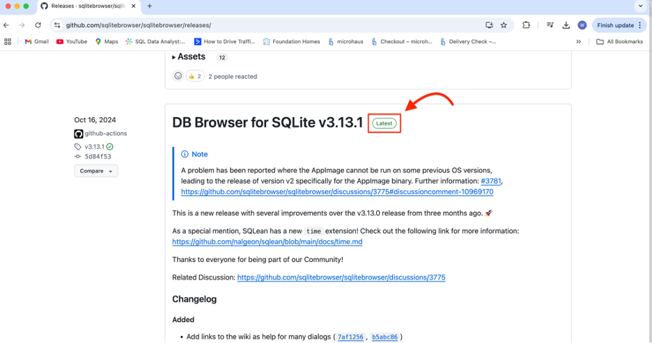

Scroll down to the Assets area within the “Latest” release section (click the triangle to the left if it is not already expanded).

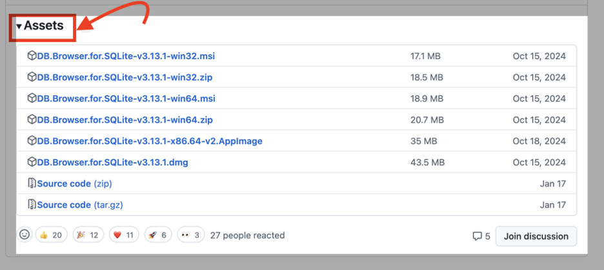

**Step 2: Download the correct file for your operating system.**

**For Windows users:**  
Under Assets, find and click the file that ends in “.**msi**”.

If you have a **64**-bit Windows, select:    
**DB.Browser.for.SQLite-vX.XX.X-win64.msi**

If you have a **32**-bit Windows, select:    
**DB.Browser.for.SQLite-vX.XX.X-win32.msi**The file will begin downloading automatically.

**For Mac users:**Under Assets, find and click the file that ends in “.**dmg**”.  
**Select: DB.Browser.for.SQLite-vX.XX.X.dmg**  
The file will begin downloading automatically.

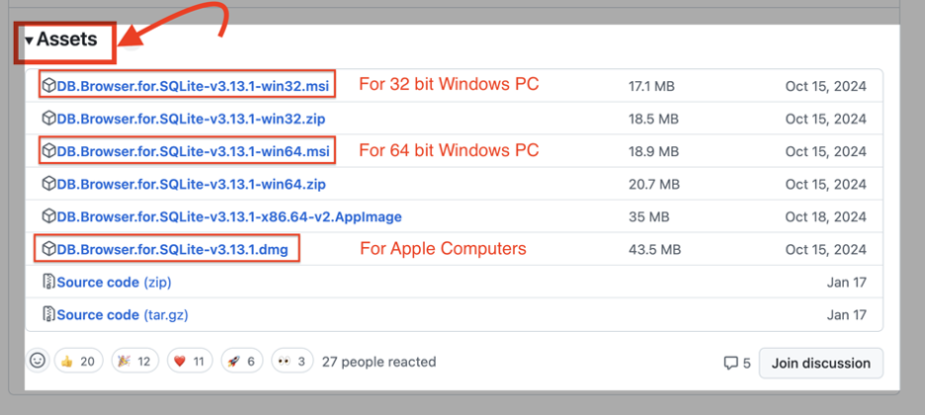

**Step 3: Install DB Browser for SQLite.**

**For Windows users:**Open the downloaded .msi file from your Downloads folder.  
Follow the installation prompts, clicking **Next** until the installation completes.  
Once installed, you can launch **DB Browser for SQLite** from your **Start menu**.

**For Mac users:**Open the downloaded .**dmg** file from your Downloads folder.  
A new window will open. **Drag the DB Browser for SQLite** icon into the **Applications folder**.  
Once done, go to **Launchpad** or **Finder > Applications** and open **DB Browser for SQLite**.  
If you see a security message, go to **System Preferences > Security & Privacy** and click **Open Anyway**.  
**You’re all set!** Once installed, DB Browser for SQLite is ready to use. You can now create, view, and edit SQLite database files.

If you run into any issues, visit the **course Q&A page and send me your questions**. Now, let’s move on to the next step in working with SQLite databases.